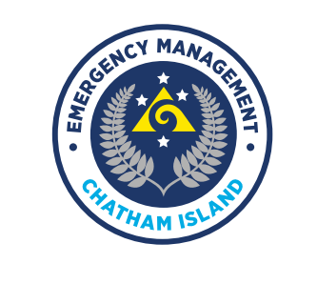
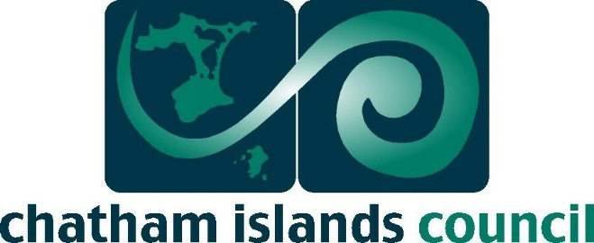

Emergency Management Resilience Co-ordinator

Job Description

Job title: | EMRC | Location: | Chatham Islands
Status: | Full-time 37.5hrs | Effective: | 2023
Group: | Chatham Islands | Department: | Emergency Management

Role of the Chatham Islands Emergency Management Office
CICEM office is administered by the Chatham Islands Council and tasked with leading and coordinating the Civil Defence Emergency Management effort of the Chatham Island Region. The Civil Defence Emergency Management (CDEM) Act 2002 directs the regions council to take steps to develop and maintain an effective level of capacity and capability across the “4Rs” of comprehensive emergency management. Reduction, Readiness, Response and Recovery.

The Chatham Islands CDEM Group vision for the region is:
To provide an efficient and effective system of emergency management that minimises the potential effect of all hazards in the community and the environment.

Purpose of the role
The purpose of this role is to develop, implement and maintain community resilience strategy ensuring effective community resilience. Ensuring the community is prepared for risks posed by hazards to the Chatham Island community across the 4R’s.

Reporting Lines

Role Specification
EMRC will support and assist the Emergency Manager across the 4R’s.
This role requires working with the community, volunteers, and Iwi/Imi, providing administration and networking through public, education awareness projects. This position requires working during an emergency event up to 12hr roster shifts.
Preparation for meetings, agendas, minutes, including CDEM Group, CEG, and Area Coordinators meetings.
The EMRC will be provided with opportunities to support their role in CDEM and be prepared to travel for professional development or meetings, including training in the CIMS structure to support the Emergency Coordination Centre personnel. Support the development and delivery of emergency management training.
Work towards a work plan that supports the CDEM Group Plan and approved by the Emergency Manager.
The EMRC will also support the emergency operation centre training.
The EMRC will be first contact with volunteers, including the Area Coordinators and support any training needed. The EMRC will organise and chair Area coordinator meetings.
Liaise directly with relevant staff from NEMA and other government and emergency agencies, business, and industry, plus CDEM partner organisations such as other CDEM Groups, Lifelines, or social service providers, agencies, and organisations.

Duty officer Role:
The EMRC will be included as part of a roster of staff under the direction of the Group Controller to carry out the role of Duty Officer as the 24/7 Emergency Management point of contact for the Chatham Islands Region: monitoring, liaising and, if necessary, initiating response action.

Functional Relationships
The EMRC will work closely with a diverse network of partners including.

Internally
Emergency Manager
Chief Executive
CDEM Group
Council Staff
Volunteers

Externally
Canterbury CDEM Group
NEMA
Government, Crown Agency
Chatham Islands Stakeholders
Iwi and Imi

Team
Work as part of the emergency management team delivering outcomes in accordance with the Group Plan’s, Group Welfare Plan’s, Chatham Islands Long Team Plan.
Lead individual work programmes and manage other team members contributions to these programmes as required.
Contribute to the wider emergency resilience teams at the regional and national levels as required.

Project Management
Lead or support the planning and delivery of projects in accordance with the CDEM Group workplan.
Evaluate all project, manage and delivery in a timely fashion.

Health and Safety
Chatham Islands Council is proactive in advocating robust Health and Safety practices; we take health, safety, and wellbeing very seriously.
So far as it is reasonably practicable you need to ensure the Health and Safety of yourself, your team, contractors, and visitors. You must comply with current Health and Safety legislation, regulations and guidelines, organisational policies, procedures, and our code of conduct.

Experience
Knowledge of Civil Defence Emergency Management (CDEM) is desirable
MS Teams is a bonus
Demonstrated ability to maintain confidentiality and remain calm under pressure.
Aware of and contribute to opportunities for process and systems improvement.
Basic understanding of the legislative requirements relevant to the processes being supported.

Person Specification
Have strong and astute interpersonal skills, relevant to both internal and external relations and communications.
Be an excellent communicator, act responsibly and be able to project a credible and dependable image, maintaining and promoting appropriate standards of integrity.
Demonstrate an ability to balance innovative and creative thinking with critical and objective analysis.
Have leadership ability, vision, and flexibility to initiate change where appropriate.
Be competitive, performance-driven and accept the responsibility and accountability for the attainment and quality of performance and financial goals
Be committed to excellent service and promote efficiency.
Display drive, energy, and enthusiasm.
Work to create high performance, achievement-oriented teams through a positive and collaborative approach
Have an ability to establish and maintain positive working relationships with Council staff, the public and other external stakeholders, including key leaders and decision-makers in the community, and other local and central government agencies.
Have a personal commitment to organisational excellence and an ability to work in a way that displays honesty, integrity, and a strong sense of business ethics.
A drive and commitment to learn, apply and succeed.
Be self-motivated and can work alone.
Be a good people person.
Have a good sense of humour.
Have an ability to weigh up conflicting information and, using logical assumptions and consideration of resources and other possible constraints, make clear, timely and decisive decisions.
Be able to take direction

