4 August 2026

Dear Chatham and Pitt Islands Community and Stakeholders,

New Chatham and Pitt Islands Shipping Service – Update 2 from 44 South Shipping
McCallum Bros Limited (MBL) and Nova Marine Carriers SA, through their joint venture 44 South Shipping Limited Partnership, are pleased to provide this second community update on the future Chatham and Pitt Islands shipping service. This update covers progress on the new replacement vessel being built for 44 South Shipping and MBL’s preparations to commence the William Fraser livestock and general-freight service.
We thank both Ministry for Cities, Environment, Regions and Transport (MCERT) (the new Ministry of Transport) and the Chatham and Pitt Islands community for their continued engagement and support.
Update in summary:
Area | Current status
New replacement vessel | As at the date of this update, the vessel currently remains on schedule for completion in accordance with the shipbuilding contract. Complex livestock ventilation design has been completed this week by our specialist designer and supplier Tecnavi, allowing construction drawings to start being produced for the shipyard to use to commence the steel cutting.
William Fraser conversion | The William Fraser vessel is currently being converted into a livestock carrier (while maintaining its ability to also operate as a general cargo vessel) with the project works in their final stages. The project works includes the installation of livestock pens, agricultural matting, additional crew accommodation, and shade canopy installation (livestock shelter).
Booking and demand planning | The proposed digital freight booking system is in final testing. Following our August community visit, customers will receive access to the digital booking portal together with booking instructions and information required to confirm demand and allocate space across the inaugural sailings. If you have initial queries, please contact us on bookings@mccallumbros.co.nz
Community visit | Our team will be on the Chatham and Pitt Islands from 9th to 14th August 2026 (inclusive) to meet with the community, customers and stakeholders to discuss the William Fraser service and provide booking system workshops.
First William Fraser sailing | The inaugural sailing is proposed to follow the route Auckland → Chatham Islands (Waitangi) → Napier, with the William Fraser anticipated to depart Auckland at the end of August 2026, subject to final regulatory approvals, operational readiness, suitable weather conditions and sufficient confirmed demand. A proposed sailing schedule will be circulated by mid-August 2026.

New Replacement Vessel:
Summary:
In accordance with the vessel construction timeline, physical construction has not yet commenced. However, the final detailed design of the livestock ventilation is now complete. The next steps are that the approved vessel design is translated into the detailed construction drawings required for the shipyard to commence the steel cutting and construction. As at the date of this update, the vessel remains on schedule in accordance with the shipbuilding contract.
Livestock Ventilation Design:
One of the more complex parts of the design process has been the ventilation fans and ducting design, which supplies clean air to the three internal livestock floors. Last week, our chosen ventilation designer and supplier, Tecnavi, completed the design, finding suitable solutions to position the ventilation fans and ducting, while minimising the impact on pen space and cargo carrying capacity on the upper deck of the vessel.
Getting this right was always going to be one of the most critical parts of the vessel's design. As a fully enclosed livestock carrier, the vessel needs to maintain a steady, consistent airflow across every part of the livestock decks, with no "dead spots." This constant flow of “clean air in and dirty air out” is what prevents dangerous ammonia build-up and ensures the animals on board receive the standard of air quality and welfare required under international standards.
The ventilation system has significant built-in redundancy. As mentioned, the current design is intended to maintain consistent airflow throughout the livestock decks and incorporates significant redundancy for critical livestock services. A dedicated secondary generator, located outside the engine room, is designed to support the ventilation system, water-making equipment and supply pumps even if the vessel’s primary power systems are unavailable.
In practical terms, this means that if livestock are on board and the vessel experiences a major breakdown at sea, the animals will continue to have clean air, fresh water and access to fodder while the technical issue is resolved and until they can be safely disembarked ashore.
Towing Tank Test:
The other design milestone is the completion of the Towing Tank Test, carried out last week in China (please see photos in Appendix 1 below). This is a well-established technique in naval architecture, where a scaled-down physical model of the vessel's hull is built and tested in a controlled body of water.
The test uses a long, narrow tank with a towing carriage that pulls the model through the water at precise speeds, while instruments measure the forces acting on the hull and how it behaves. The main purpose is to measure the drag, or resistance, the hull experiences moving through the water. This resistance varies depending on hull shape and vessel design and it directly informs the vessel's design speed, which helps confirm fuel consumption estimates while ensuring the correct propellor size/model is chosen
It might seem like an old-fashioned approach in today's world of computer modelling, but towing tank testing is still standard practice across the shipbuilding industry, particularly as a way of verifying Computational Fluid Dynamics (CFD) modelling and confirming that the computer-based results hold up in the real world.
Next Steps:
With all the major equipment for the vessel now ordered, the next major milestone in the build is the steel cutting ceremony, which will formally mark the start of construction. We will share a further update once this milestone has been reached and as construction progresses. Commencement of steel cutting is anticipated to occur in late September 2026.

William Fraser – Commencement Shipping Service Update:
In parallel with the replacement vessel project, MBL is completing the conversion of its 68m landing craft William Fraser so she can be used as both a livestock carrier and general cargo vessel servicing the Chatham and Pitt Islands. Please see photos of the project’s progress at Appendix 1 and the William Fraser vessel particulars at Appendix 2.
The intention is for the William Fraser to assist with moving livestock from the Islands to the mainland, with an initial focus on supporting the farming community and providing additional resilience to the Chatham and Pitt Islands supply chain while the replacement vessel is being built.
The William Fraser will transit between the Chatham and Pitt Islands and the mainland regularly until Christmas 2026, at which point MBL will assess the demand and adjust the sailing schedule accordingly. Subject to demand and other shipping contracts, MBL intends to make the William Fraser available to undertake one trip per month until the replacement vessel is operational.
Longer term, the William Fraser will be a dedicated “back-up” vessel to support the Chatham and Pitt Islands service once the new vessel is in service. For example, it would be used when the replacement vessel is drydocked to overhaul major machinery items, repaint/antifoul her hull and undergo general maintenance.
The status of the conversion works is as follows, with final completion and sign-off expected in mid-August 2026 and the first sailing to the Chatham Islands (Waitangi) from Auckland at the end of August 2026:
- Livestock pens and deck works: The aluminum livestock pens have been fabricated and delivered onboard the William Fraser.
- Agricultural/Dairy matting: The matting is standard heavy duty dairy matting used in milking sheds around the country and has been installed across the livestock deck to provide secure footing and improve animal-welfare outcomes.
- Crew accommodation: Additional crew accommodation has been installed to provide accommodation for a dedicated stockperson during livestock voyages.
- Livestock Shelter canopy: The livestock shelter canopy is being manufactured, with the key function of this canopy to keep salt spray off the livestock when in transit. The livestock area of the William Fraser has 3m high side walls, which also provides additional shelter to livestock from wind and spray while at sea. There is significant air flow to circulate fresh air through the livestock deck, as the William Fraser livestock decks are sheltered, but are non-enclosed.
- Livestock Loading Ramps: Purpose-built livestock loading ramps are under construction to enable livestock to be transferred from the Pitt Island barge to the William Fraser at a suitable location off Pitt Island and to support loading and unloading at Waitangi and mainland New Zealand ports.
- Troughs, waterline, feed: Livestock troughs for feed and watering on board the William Fraser have been delivered, with freshwater lines being installed to provide each pen with freshwater access during the voyage.
First Voyages:
The first voyage for the William Fraser will have the following route: Auckland to Chatham Islands (Waitangi) to Napier.
Upon completion of this voyage, the William Fraser will transit between Napier and the Chatham Islands (both Waitangi and Pitt Island) consistently during the month of September 2026 with the aim of supporting farmers in reducing stock densities on island. For the initial voyages, Napier will be the port of call on the mainland for the William Fraser. The shorter sailing distance between the Chatham and Pitt Islands and Napier improves the economic efficiency of the service while freight demand is established and operating patterns are refined.
For these initial voyages, the only livestock able to be transported by William Fraser is cattle. This is because the William Fraser is not currently approved by the Ministry of Primary Industries (MPI) to transport sheep. The transport of sheep using this vessel will be restudied once the initial trips have been completed.
The William Fraser is equipped with a forklift and a 30-tonne excavator fitted with a wire winch. Together, these will be used to load and unload general cargo between the wharf and the vessel. The excavator will undertake the primary lifting operations, with the forklift repositioning cargo within the hold for efficient stowage and securing prior to departure.
The vessel is capable of carrying a wide range of general cargo and breakbulk freight to the Chatham and Pitt Islands. However, the primary focus of the return voyages will be cattle, with limited quantities of return freight carried where operationally practicable and space permits.
The William Fraser is also fitted to carry two 20-foot refrigerated containers, providing capacity for fresh and frozen palletised goods as required. In addition, the vessel’s bow ramp enables the efficient loading and discharge of larger vehicles, machinery and project cargo at Waitangi.
Pricing, Fuel Adjustment Factor (FAF) and Freight Capacity:
When developing our freight rates, our objective has been to keep pricing as closely aligned as possible with the current Chatham Island Shipping Limited (CISL) freight rates to minimise any price shocks for the Chatham and Pitt Islands community, while ensuring the William Fraser shipping service is economically viable. At the same time, we have sought to introduce a simple and transparent pricing structure.
MBL recognises that moving to a new pricing model may raise questions as customers become familiar with the new system. We are committed to being open about how our freight rates have been developed and welcome any feedback.
Please refer to the Schedule of Rates at Appendix 3 and the Fuel Adjustment Factor (FAF) Schedule at Appendix 4. If you have any questions or concerns regarding the new pricing structure, please contact us at projects@mccallumbros.co.nz
Fuel Adjustment Factor (FAF):
As part of the new pricing model, we have reset the baseline freight rates using a contemporary fuel price (prior to the market disruptions associated with the Iran conflict). This means the published freight rates reflect the cost of freight under normal market conditions, with only the FAF varying as fuel prices increase or decrease. Importantly, the FAF is a two-way adjustment. If fuel prices increase, the applicable FAF will increase. Equally, if fuel prices decrease, the FAF will reduce and customers will receive the full benefit of those lower fuel costs through a corresponding reduction in the freight charge. To ensure complete transparency, at the beginning of each month, or before each voyage (whichever occurs first), MBL will publish:
- the latest fuel price provided by our nominated fuel supplier;
- the FAF calculation; and
- the applicable FAF percentage.
This information will be provided directly to customers by email and published on the MBL website.
Cattle Freight Rate:
The new cattle freight rate has been designed to provide a simple $/kg plus GST and the applicable FAF pricing model. Unlike the current system, animal handling fees are included within the freight rate, meaning MBL will not charge a separate handling fee.
As is currently the case, Chatham Islands Council (Council) dues will continue to be charged separately and collected by MBL on behalf of the Council.
MBL understands that the current CISL pricing for a 350 kg animal is approximately:
- Base freight rate: $0.63/kg.
- Fuel Adjustment Factor (as of July 2026): 25%.
- Animal handling fee: $13.60/head.
- Council dues: $5.00/head (collected on behalf of the Chatham Islands Council).
This equates to:
- Freight (including FAF): $0.7875/kg.
- Freight cost for a 350 kg animal: $275.63.
- Plus handling fee: $13.60.
- Total freight charge: $289.23 (excluding Council dues).
- Equivalent freight rate: approximately $0.83/kg.
Accordingly, the proposed MBL freight rate from Pitt Island to Napier is $0.85 per kilogram plus the applicable FAF, exclusive of GST. This is inclusive of animal handling fees and is intended to provide a simple and transparent pricing model while remaining broadly consistent with the overall cost currently incurred by customers under the existing CISL pricing structure.
For the avoidance of doubt, the Schedule of Rates as set out in Appendix 3 are for the William Fraser shipping service only and not the shipping service to be undertaken by the replacement vessel.
Cargo Carrying Capacity:
The William Fraser has been configured to maximise freight flexibility, allowing livestock and general cargo to be carried efficiently while supporting the future replacement vessel once it enters service. Please note that the initial voyages between Auckland and the Chatham Islands, and between Napier and the Chatham Islands, will not utilise the William Fraser's full cargo-carrying capability. During the commencement phase of the service, the primary focus will be on safely establishing the cattle carrying operation, with the range and volume of general cargo carried increasing over time as operational procedures are refined and demand is confirmed.
Mainland New Zealand to the Chatham Islands:
The William Fraser can carry up to approximately 1,800 tonnes of cargo, including:
- General cargo (e.g. timber, breakbulk cargo, palletised freight, tanks and other project cargo);
- Chilled/Frozen goods (via two onboard 20-foot refrigerated containers);
- Machinery and vehicles; and
- Bulk fuel (up to approximately 200 tonnes), if required in the future.
Chatham Islands to Mainland New Zealand:
The William Fraser has approximately 430 m² of dedicated livestock pen space, together with the ability to carry limited general cargo where operationally suitable. Indicative livestock capacities are:
- Cattle: Approximately 390 head, based on an average liveweight of 300 kg.
- Sheep: Approximately 1,350 head, based on an average liveweight of 45 kg.
These figures are indicative only and are based on the livestock loading densities approved by Maritime New Zealand. The actual number of animals carried on any voyage will depend on factors including the type of livestock, average liveweights, animal welfare requirements and the overall cargo mix for that sailing.
Please note: As mentioned above, initial voyages will not include sheep, as the William Fraser is not yet approved by the MPI to transport sheep. MBL will keep the community informed should this position change in the future.
Return General Cargo:
Subject to the livestock consignment and operational requirements for each voyage, there may also be opportunities to transport limited quantities of general cargo from the Chatham Islands to mainland New Zealand, for example, wool bales and frozen, chilled and/or dry goods. The availability of return freight capacity will be assessed on a voyage-by-voyage basis, and customers are encouraged to contact MBL in advance to discuss their freight requirements.

Digital Booking System and Customer Onboarding:
MBL has developed a digital booking platform to help coordinate livestock and general freight movements across its coastal and Chatham and Pitt Islands shipping services.
The system is currently in final internal testing. It is intended to allow customers to submit booking requests online for livestock and general freight, make online payments, view sailing information and updates and provide relevant livestock movement documentation.
The system will be introduced in stages. We will provide tutorials and practical support when on Island in early August. Longer term, the booking system will be expanded and refined for the replacement vessel once it enters service, adopting efficiencies and learnings from its use for the William Fraser shipping service.
Early August Chatham and Pitt Islands Visit:
Members of our team will be on the Chatham and Pitt Islands from 9 to 14 August 2026 (inclusive) to meet with customers and other community stakeholders about the William Fraser service. This will include staying on Pitt Island the night of 10 August. During this visit, we intend to:
- discuss commencement of the William Fraser service and the proposed sailing schedule;
- confirm expected livestock and general freight demand;
- demonstrate the digital booking system and assist customers with account setup;
- discuss livestock-agent, purchaser and payment arrangements;
- explain the Terms of Trade and booking conditions (to be circulated early August 2026);
- work through port logistics, loading arrangements and customer requirements; and
- receive community feedback before the inaugural sailing.
We will confirm the exact dates, times and locations for these sessions shortly.
Demand planning:
MBL will circulate detailed booking instructions via our digital booking portal, for the inaugural sailing departing from Auckland, together with indicative schedule information for the sailings in September 2026.
To help us plan the inaugural sailing and the on-going sailing schedule we will require the following information, which will be submitted through the digital booking portal:
- the number and type of livestock you expect to move;
- estimated weights of each consignment of livestock;
- your loading location and destination port;
- your livestock agent, buyer or paying party (including their contact details); and
- any general freight, machinery, or special handling requirements from the Ports of Auckland for the inaugural sailing).
This information will help us confirm demand, allocate space, finalise port logistics and make the inaugural sailing as efficient as possible.
Next Steps:
For completeness, the next steps prior to the William Fraser’s inaugural sailing are:
- Complete the remaining William Fraser conversion works and final commissioning activities;
- Sign off of all regulatory approvals and operational readiness checks;
- Provide the new digital booking system link and information;
- Confirm likely demand and customer account arrangements; and
- Confirm the first sailing schedule, booking cut-off dates, loading arrangements and customer information pack.

We again would like to thank the Chatham and Pitt Islands community for your engagement to date. If you have any questions, including suggestions on what customers want to see and how things can be improved, please reach out to us at: bookings@mccallumbros.co.nz
Yours sincerely

Callum McCallum
Director
44 South Shipping GP Limited
projects@mccallumbros.co.nz

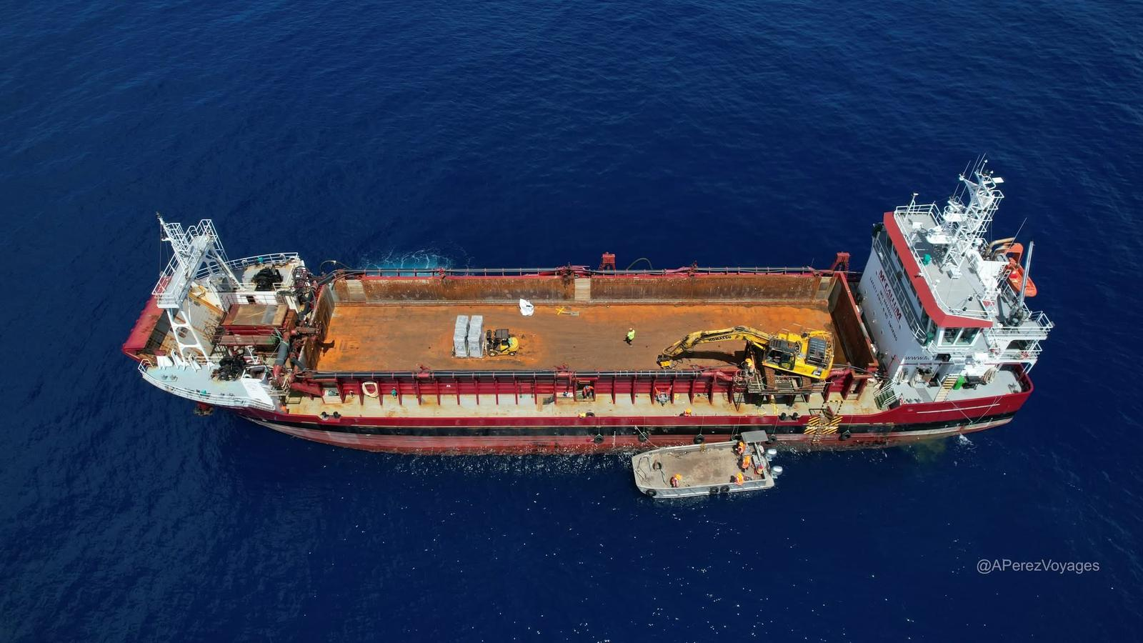
APPENDIX 1 – PHOTOS
Figure 1: The 68m William Fraser at Tokelau: 2025.
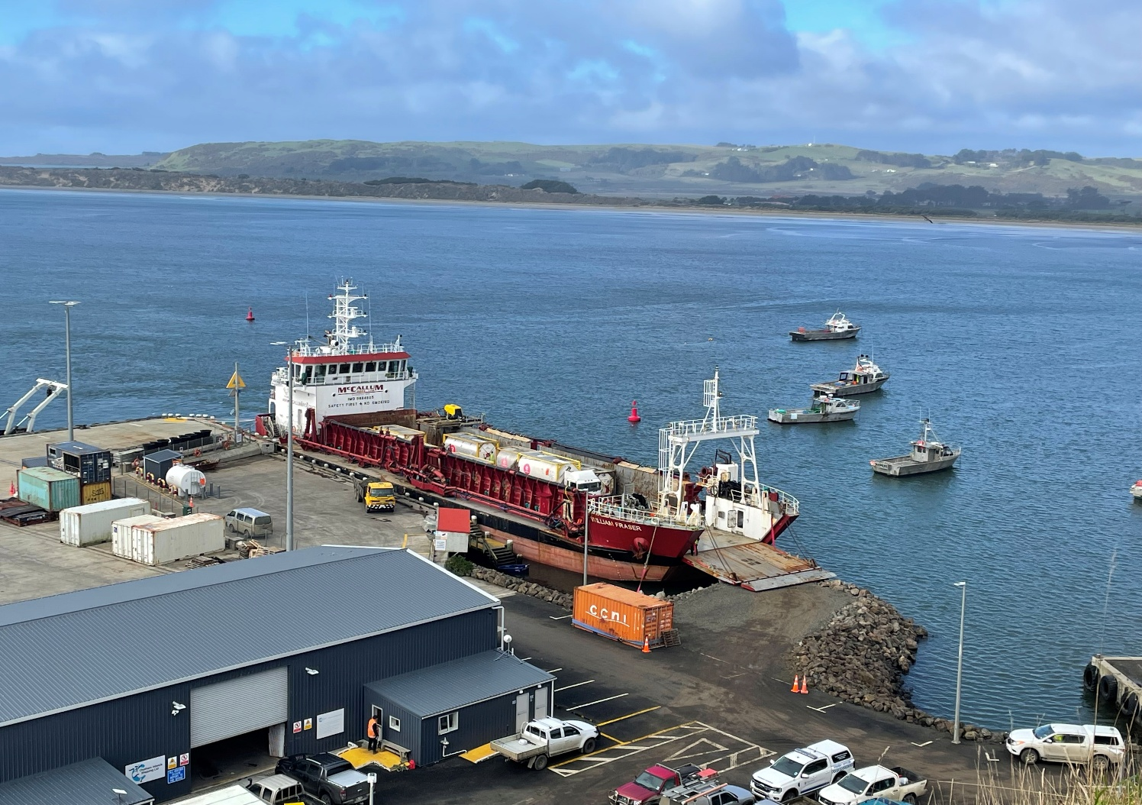
Figure 2: The 68m William Fraser at Waitangi: 2024
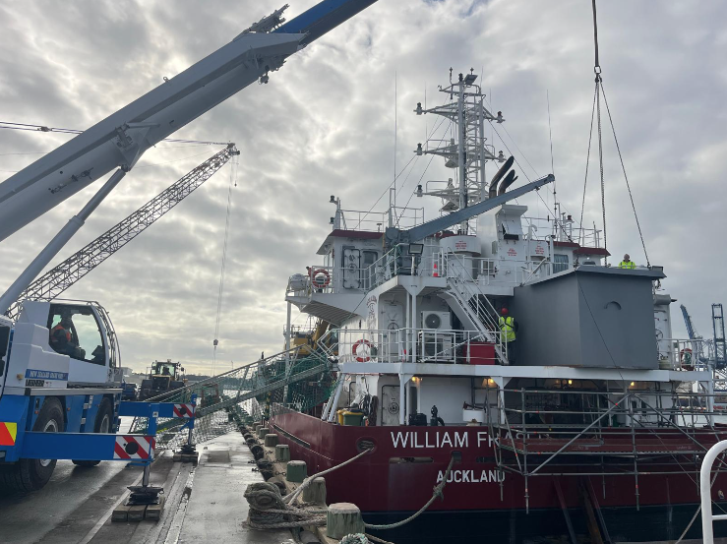

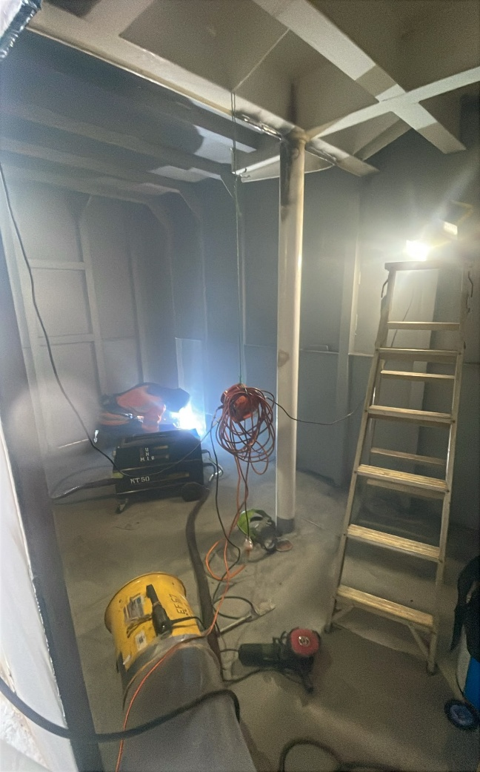
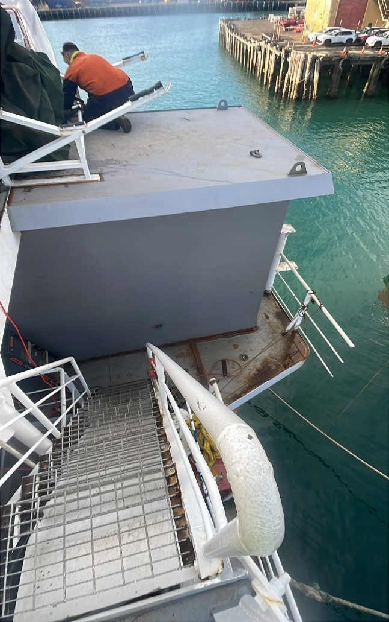

Figures 3 - 6: Cabin modifications onboard the William Fraser: July 2026

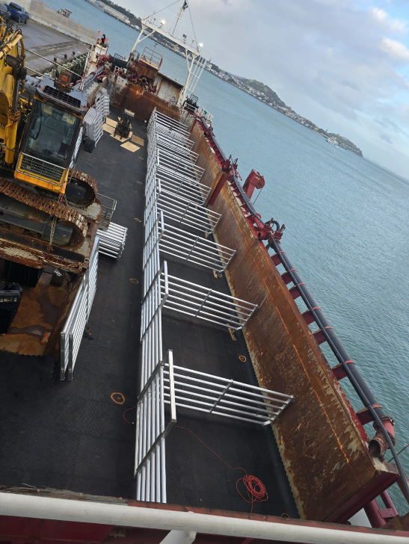
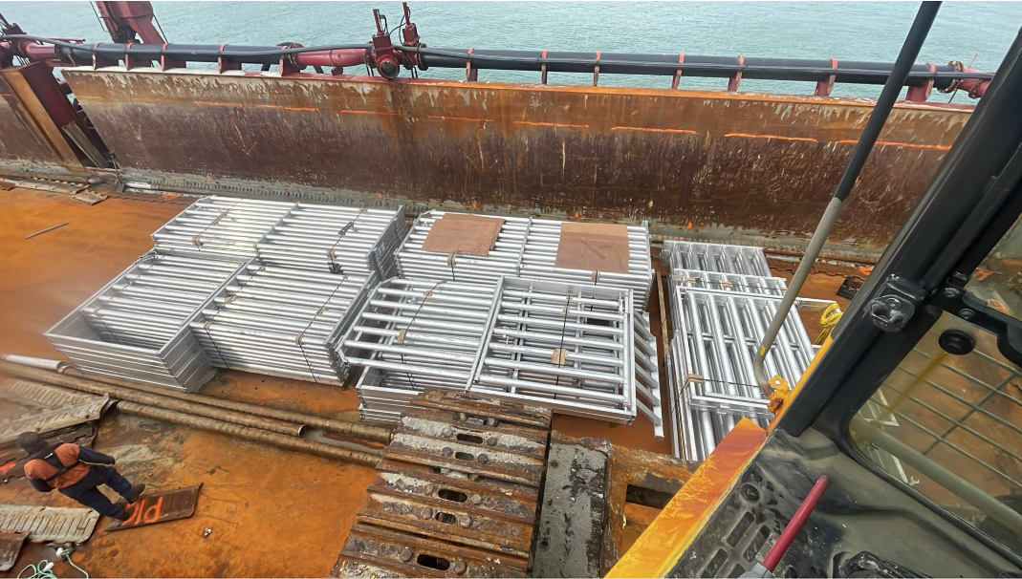

Figures 7 - 8: Aluminum livestock pens and dairy/agricultural matting: July 2026
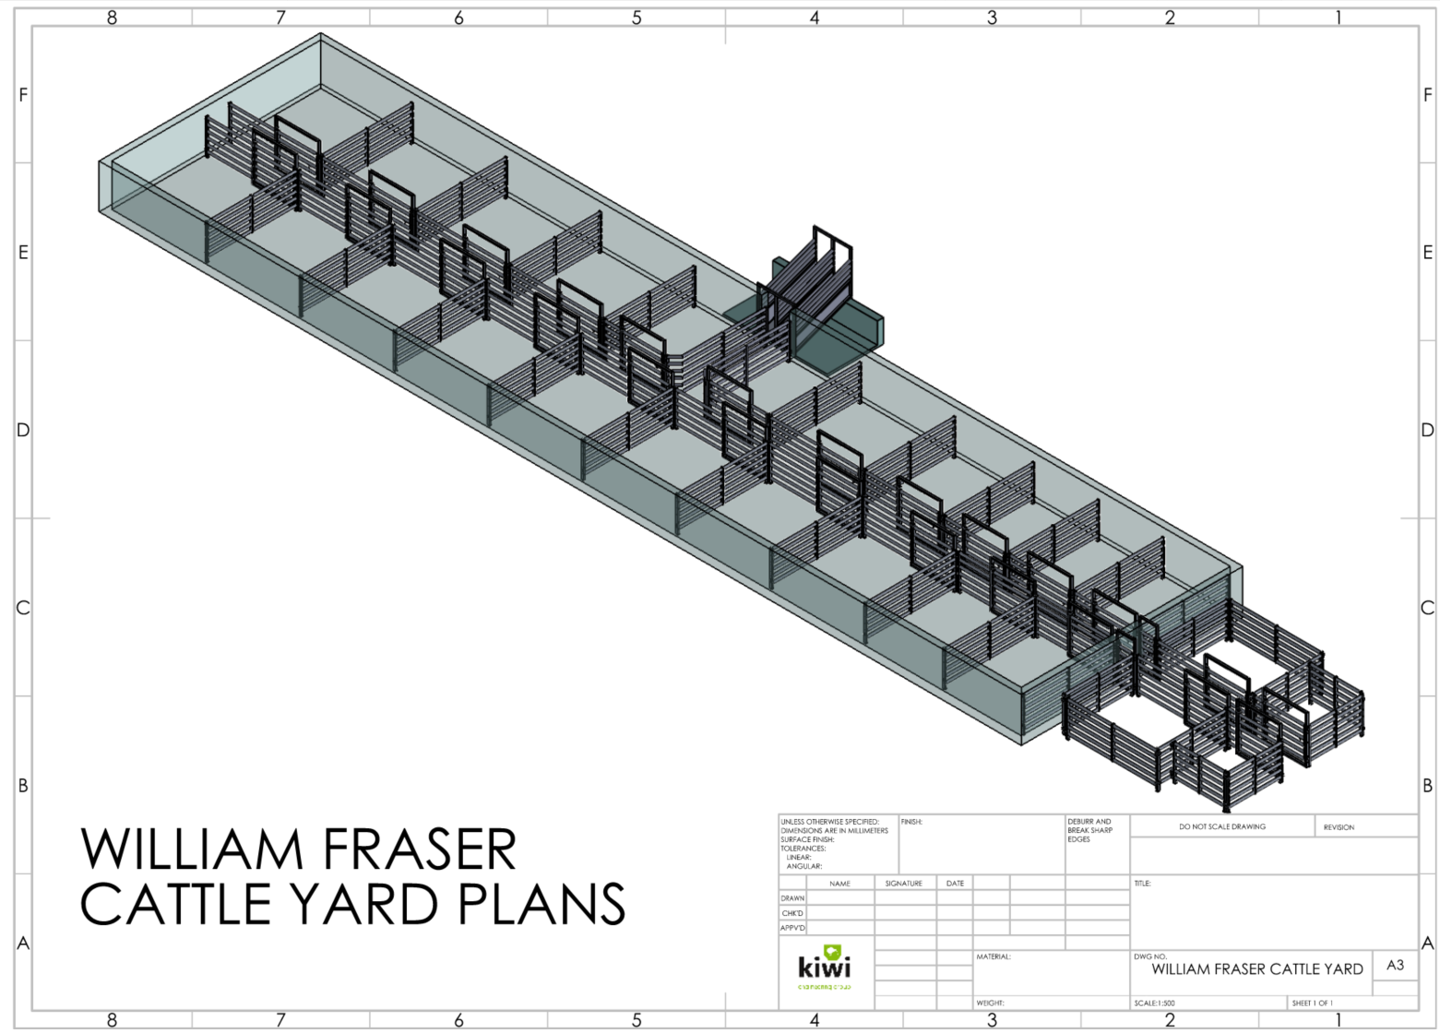
Figure 9: 3D view of cattle yards set up inside the William Fraser
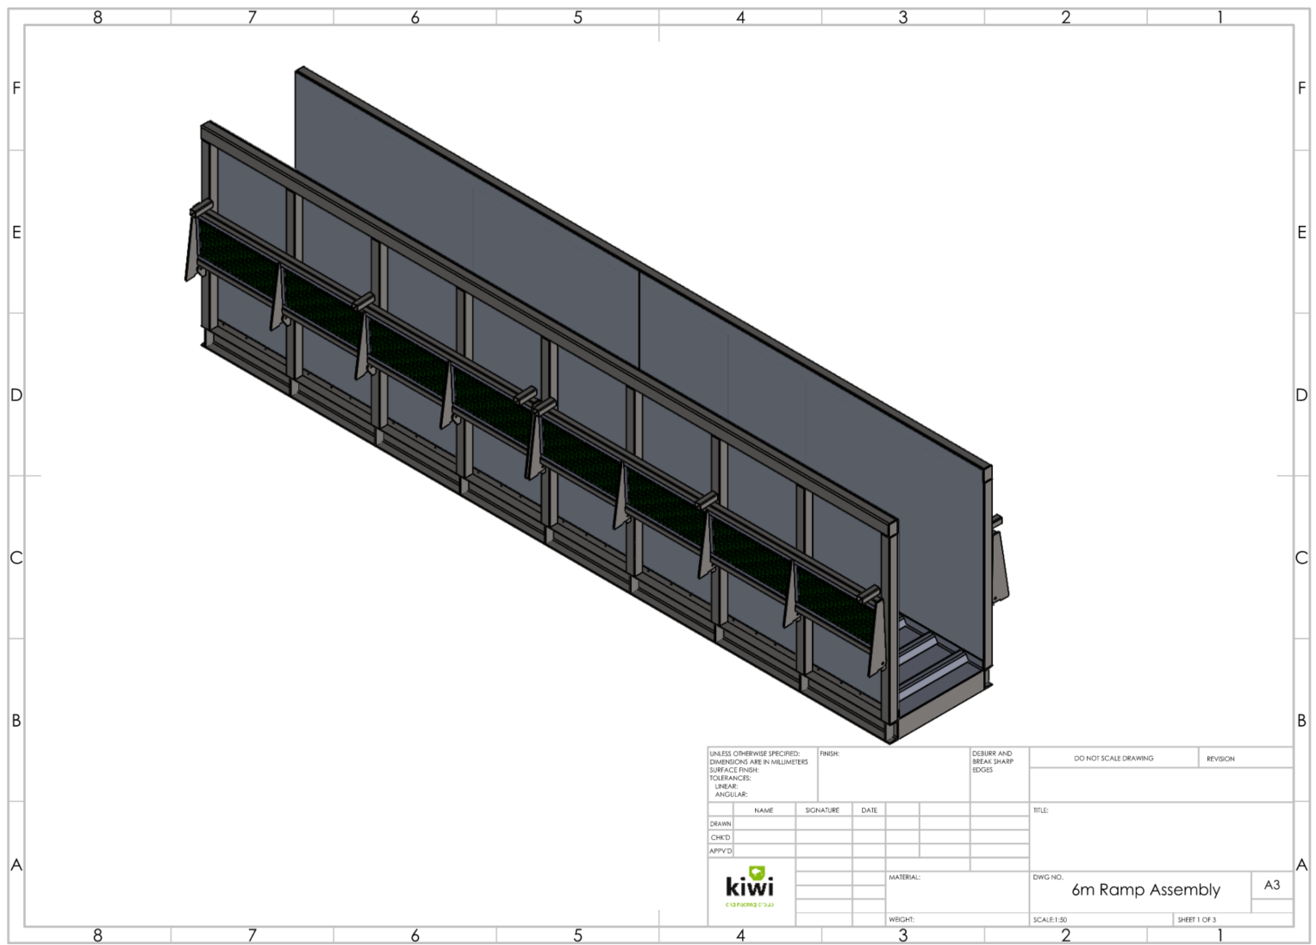
Figure 10: Livestock loading ramp currently under construction
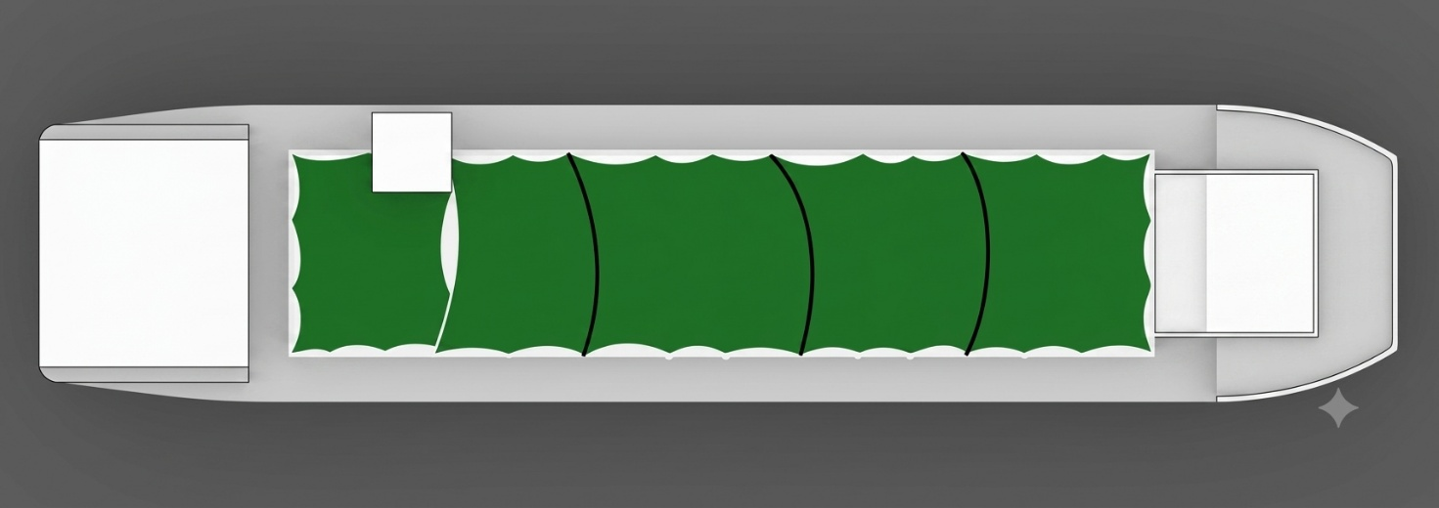
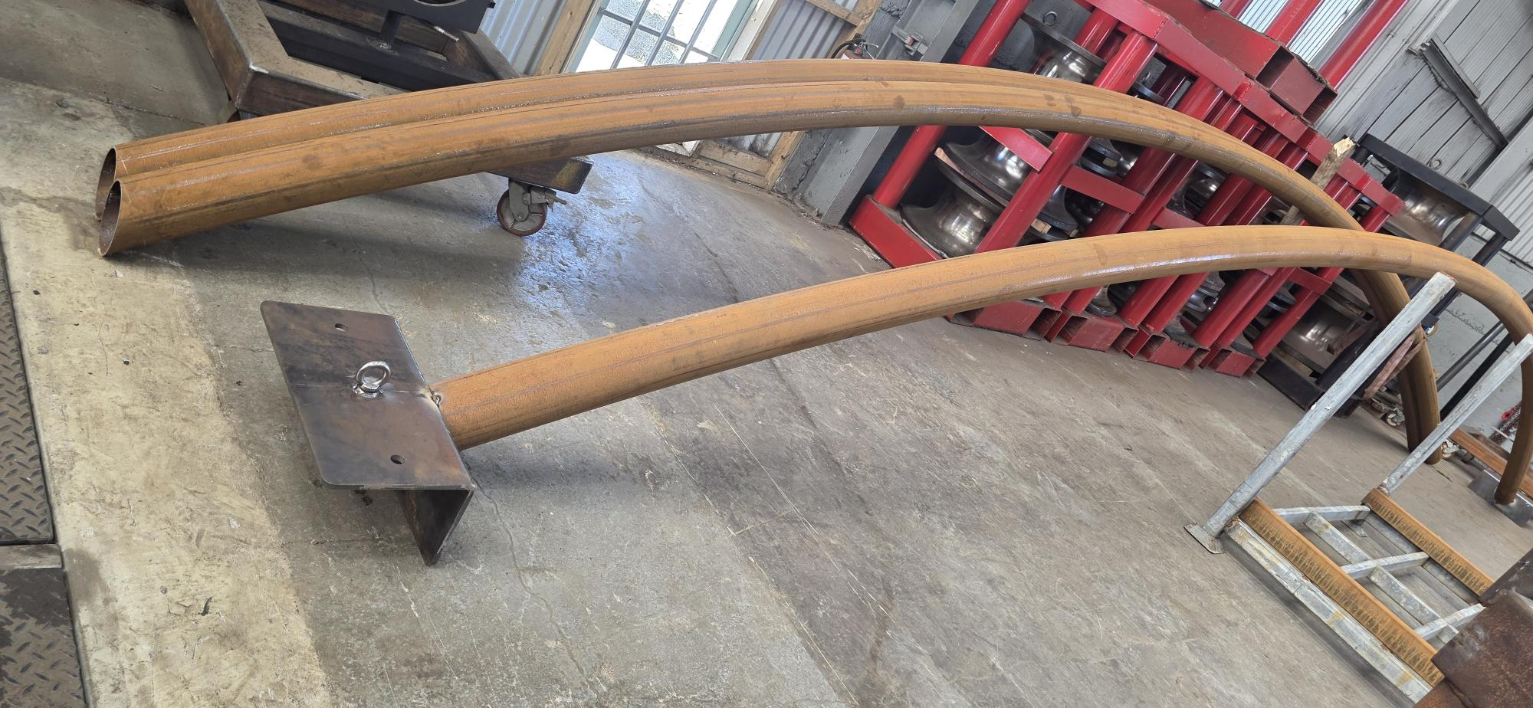
Figure 11: Shade canopy system concept, including support brackets being fabricated. This canopy will cover the whole bin, sheltering livestock from salt spray and exposure.
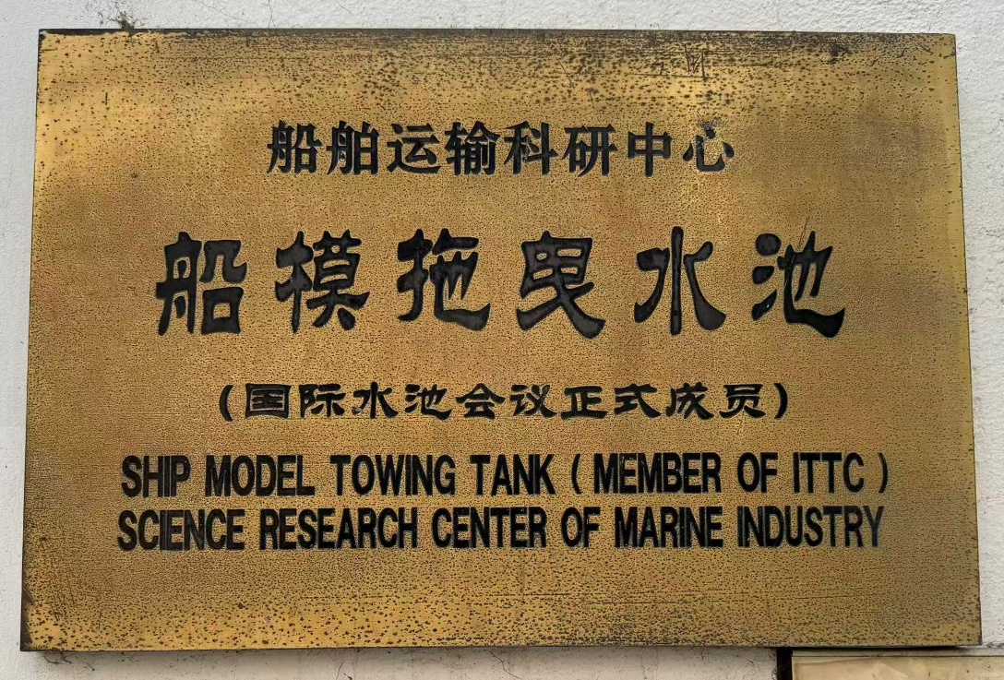
Figure 12: New Vessel – Tank Test Location: 30 July 2026
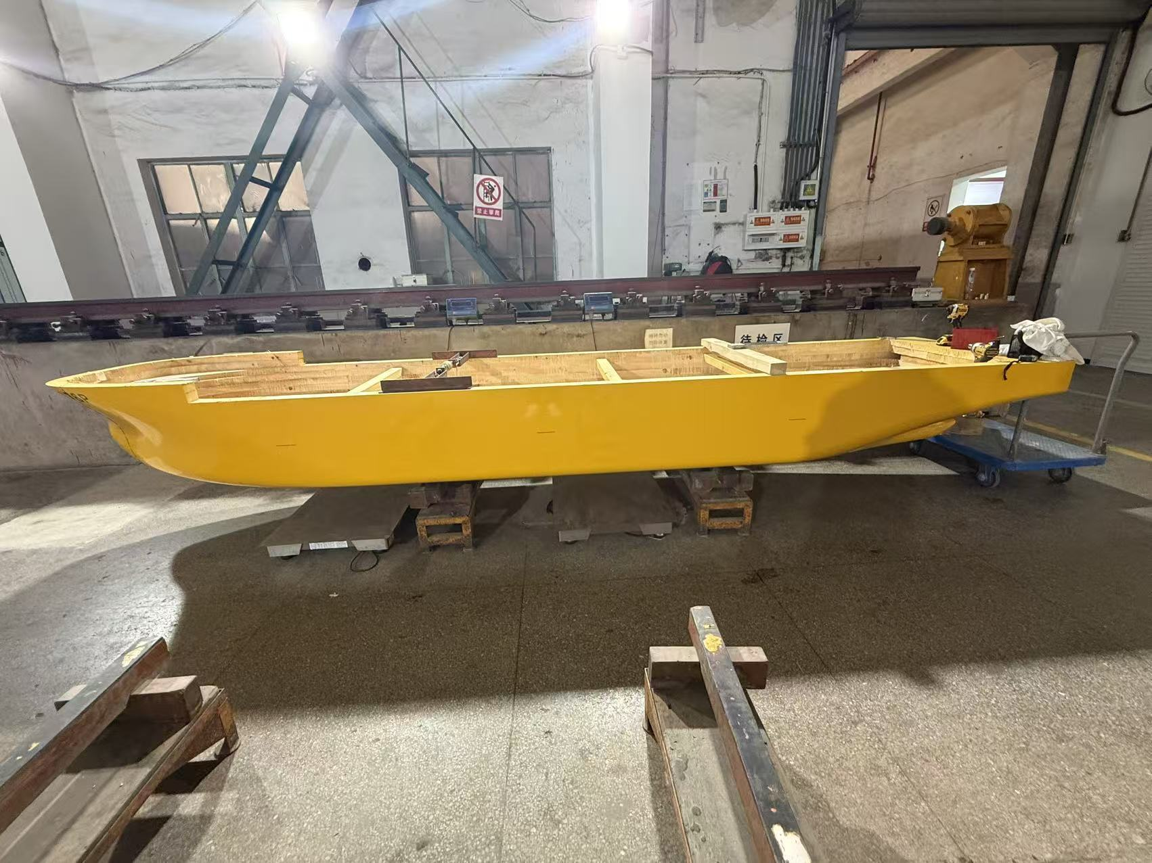

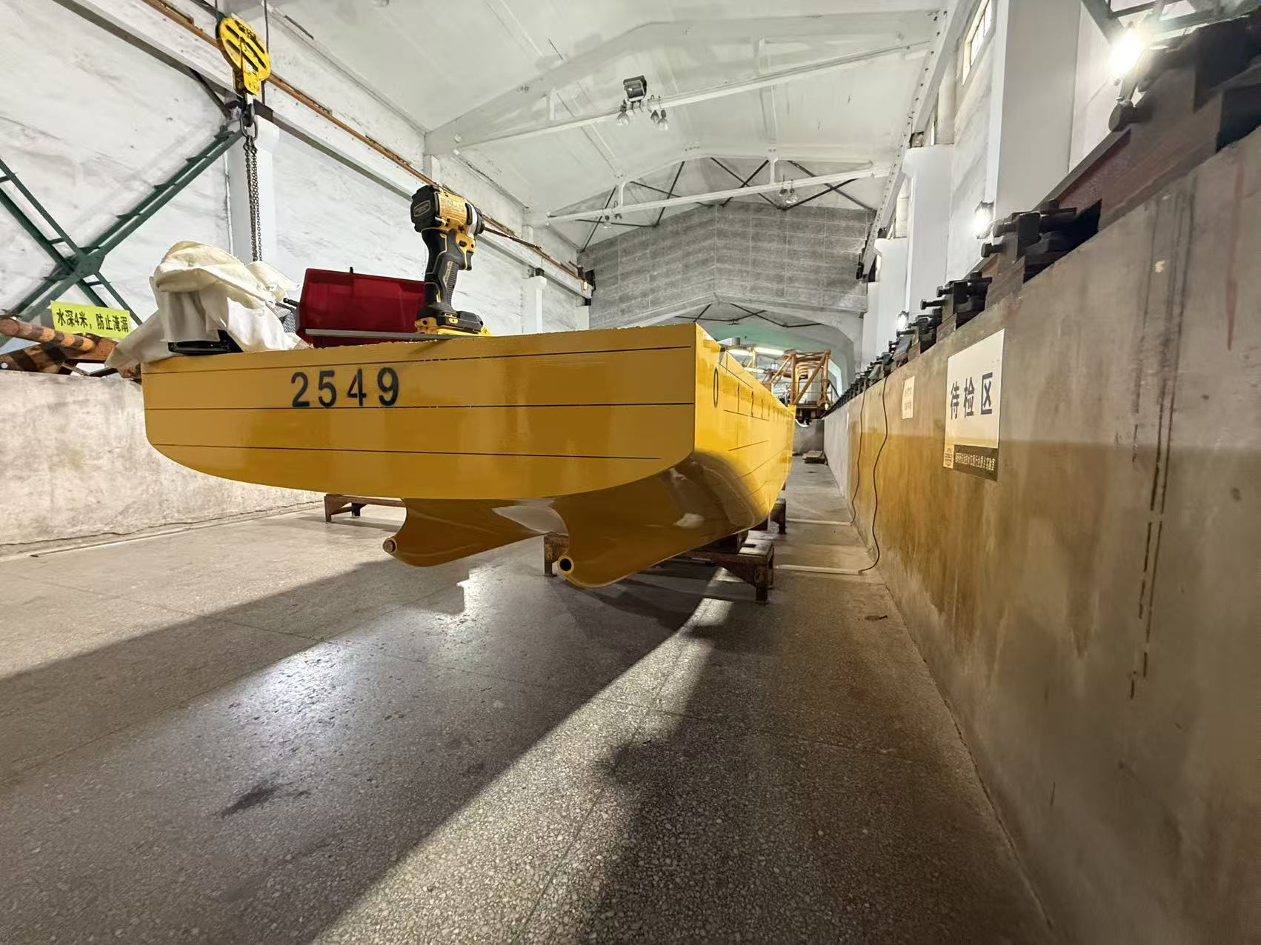

Figures 13 - 14: New Vessel – Tank Test Hull Model: 30 July 2026

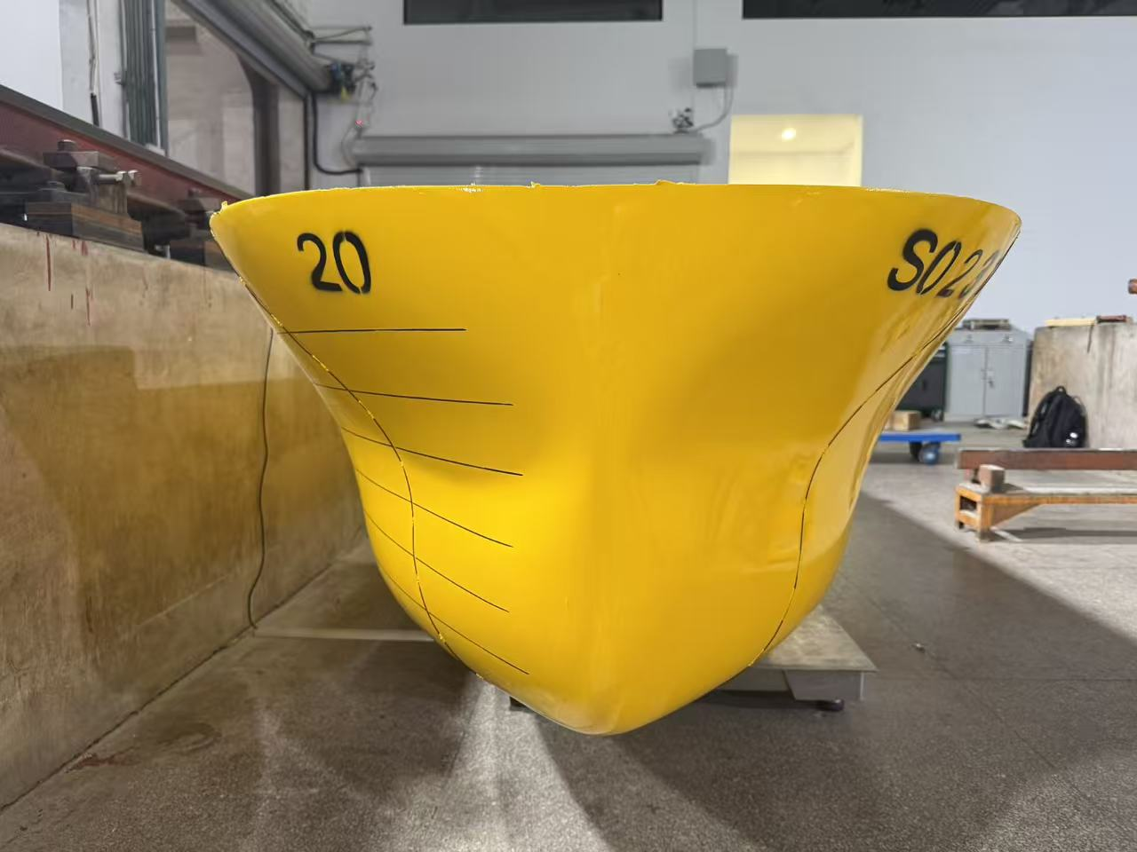

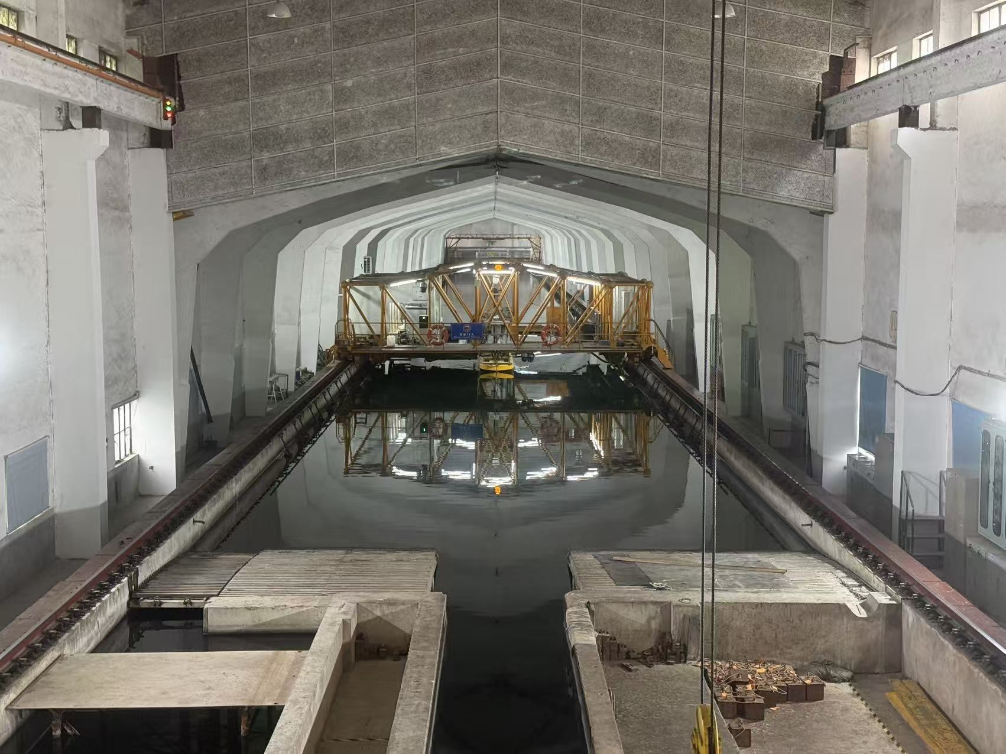

Figures 15 - 16: New Vessel – Tank Test Hull Model and Test Tank: 30 July 2026

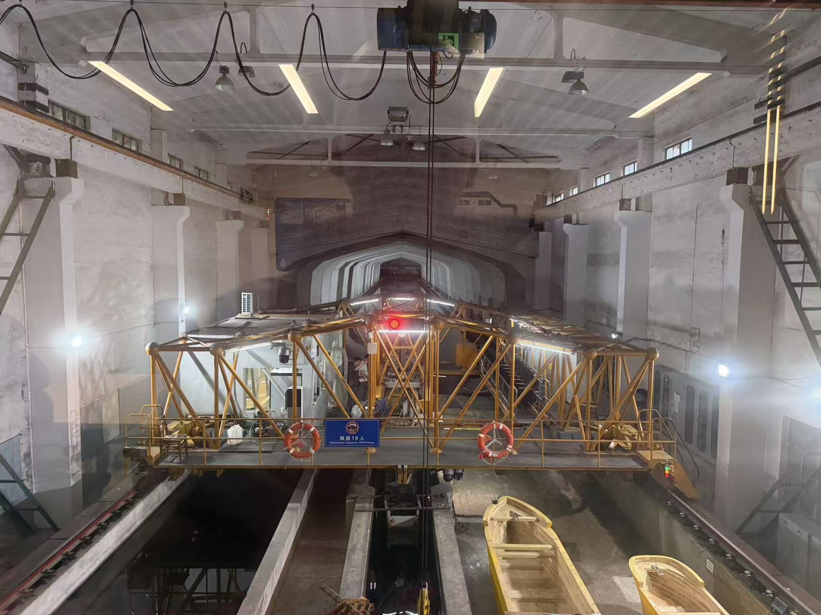
Figure 17: New Vessel –Test Tank: 30 July 2026

